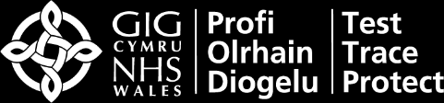



•

Wait at least 30 minutes after you last ate or drank anything before starting the test

•

Don’t start it if you’ve had a nosebleed in the past 24 hours

•

If you have a piercing, swab the nostril on the other side. If both sides are pierced, remove jewellery

•

If you can’t take a throat swab (for example if you’ve had a tracheostomy) swab both nostrils instead

•

Before you start wash your hands for 20 secs in soap and warm water or use sanitiser

•

Use a clean, flat surface and, if doing more than one test, make sure to sanitise your hands each time

Read the instructions that came with

your kit carefully. Take the test strip

out of its pack and place it onto the

cleaned flat surface. Once opened,

start the test within 30 minutes.

Blow your nose, wash and dry/sanitise

your hands again. Remove the swab

being careful not to touch the soft part.

Remove the swab carefully

without touching your teeth,

tongue or gums.

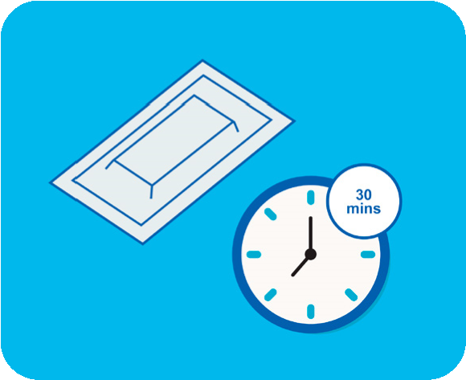

1

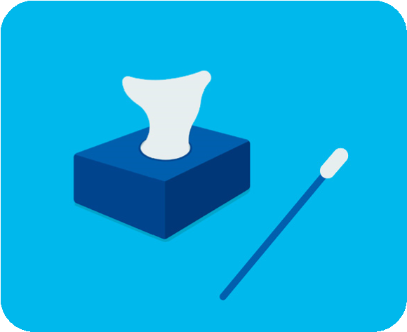

1

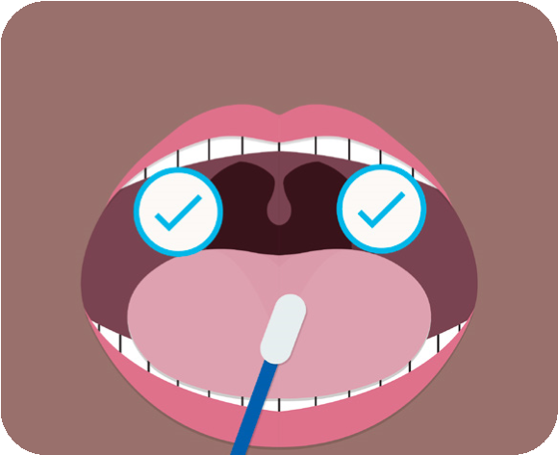

4

Twist or snap open the extraction buffer

sachet, being careful not to spill any of

the fluid. Open the tube and pour in all

the fluid from the sachet.

Open your mouth wide and use a

mirror to locate your tonsils (or where

they used to be).

Insert the same swab inside your

nostril until you feel resistance,

making sure you don’t touch any

other part of your face.

Close the extraction tube cap and

place the filled tube in the tube

holder.

Do this firmly 4 times on each side.

Use a mirror to help you do this

correctly.

Roll the swab firmly around the

inside of the nostril, making 10

complete circles.

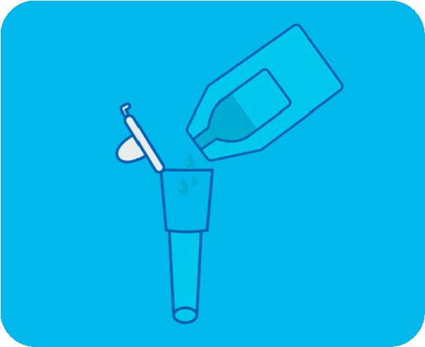

2

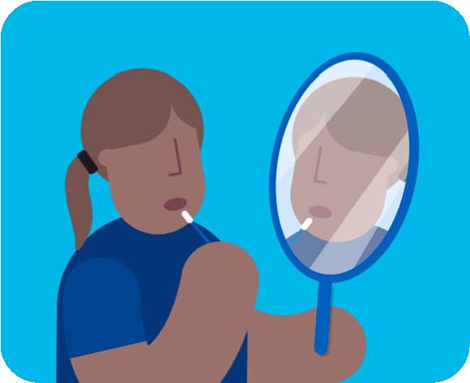

2

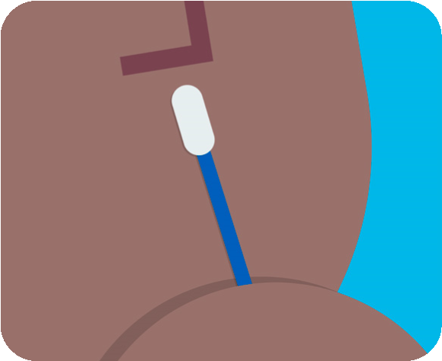

5

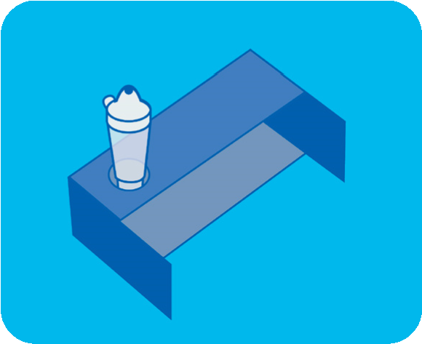

3

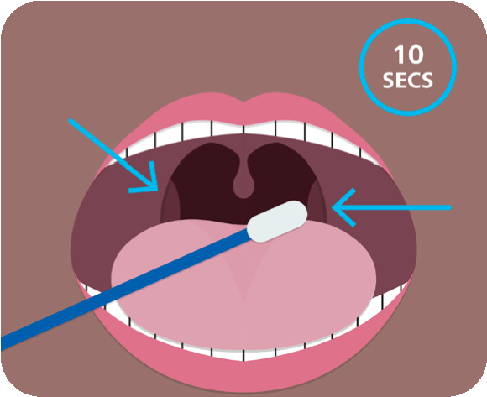

3

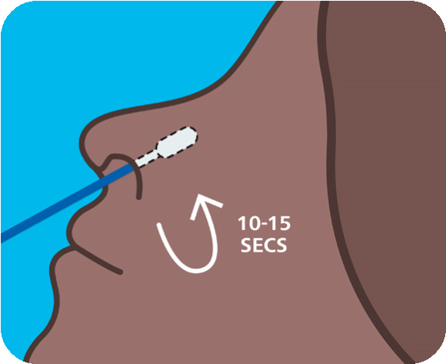

6

**How to Do a Rapid**

**COVID-19 Self-Test**

**Instructions before starting**

**Preparing your test**

**Doing your test**

x4

x10



To report your result you need the barcode on the test strip (or the ID number under it).

You can report your result either online at

**www.gov.uk/report-covid19-result**

or call

**119**

.

Pick up the tube, open the lid and

place the fabric tip of the swab into

the tube so it is in the fluid.

Pinch the tube as you remove the

swab to make sure that all the fluid

is removed then dispose of the

swab in the waste bag provided

Make sure that you are dropping

fluid and not an air bubble. Set a

timer for 30 minutes.

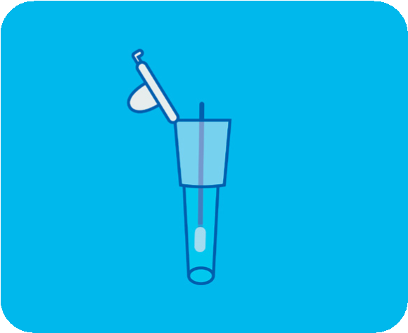

1

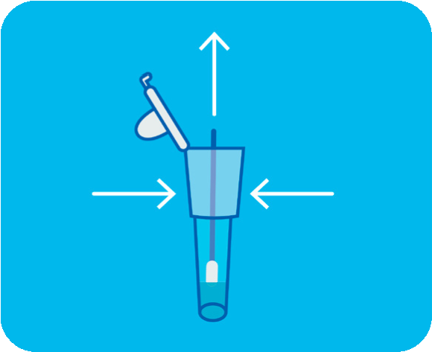

4

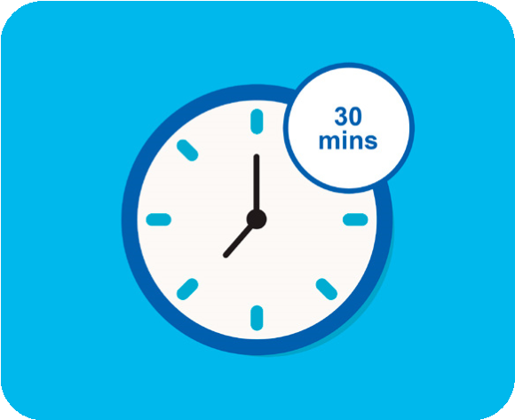

7

Press the tip against the edge of the

tube with force.

Press the nozzle cap tightly on to

the tube to avoid any leaks.

Within 10 mins, you should see

a line at ‘C’. If C line is not visible

within 30 mins, the

test is invalid.

Roll the swab around the tube for

seconds. It is important to mix

15

thoroughly.

Gently squeeze the extraction

tube to place 2 drops of the fluid

onto the specimen well marked

‘s’ on the test strip.

If after 30 minutes you still have

only one line, your result is negative.

If you have two lines, then your

result is positive.

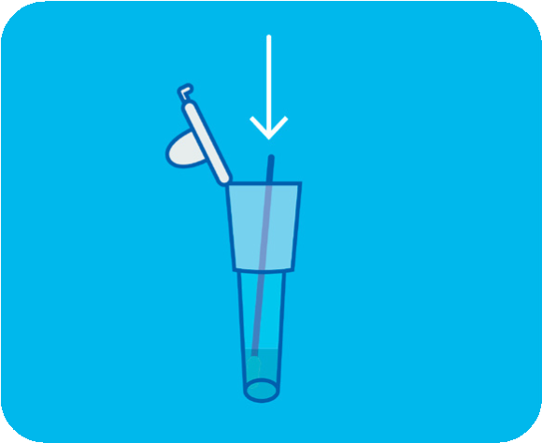

2

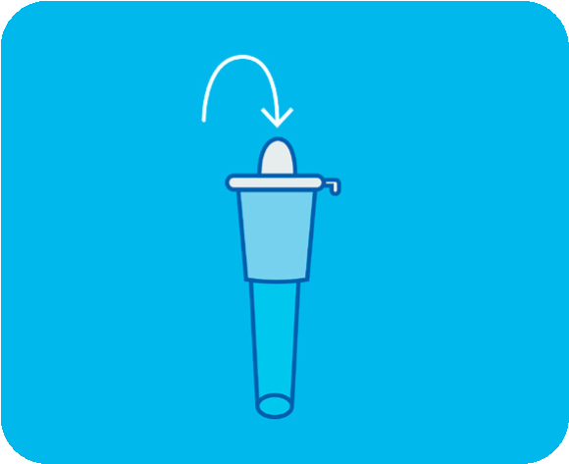

5

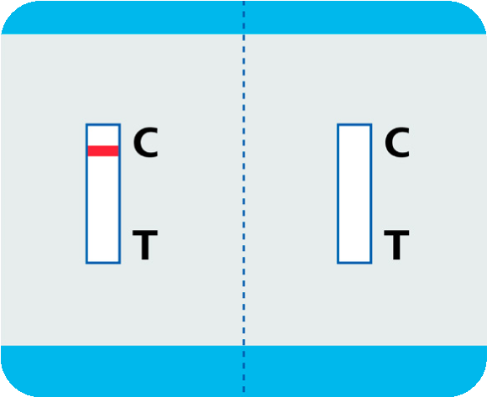

8

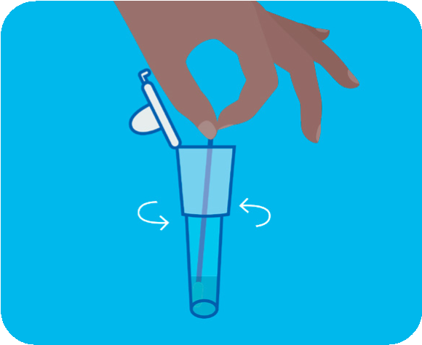

3

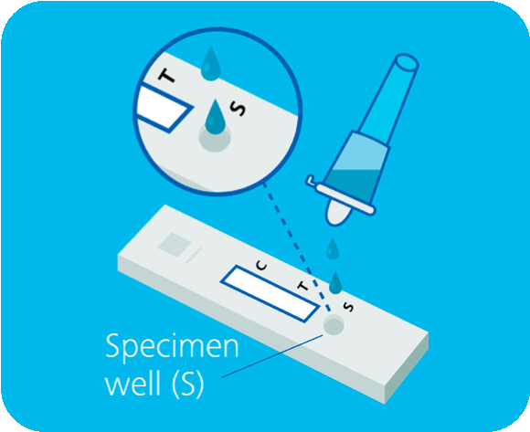

6

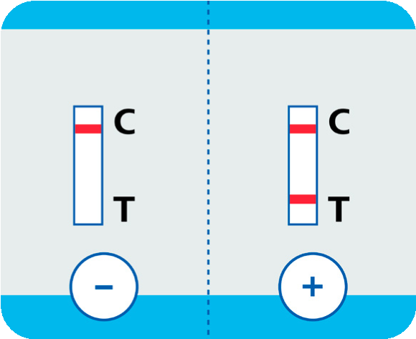

9

**Processing your test**

**Now report your result**